NUTRIENT MANAGEMENT IN CASHEW

Importance of soil nutrient management in cashew

Cashew is grown along the west coast and east coast of India. Most of the cashew growing soils are low in fertility status, and it is one of the major factors for the low productivity of cashew in India. Like any other crops and organism, cashew too requires additional nutrient inputs for producing potential yield. Being a perennial tree crop, cashew removes a considerable amount of nutrients from the soil. The amount of nutrients removed by a cashew tree (30 year old) is reported as 2.847 kg N, 0.75 kg P₂O₅ and 1.265 kg K₂O. If the continuous removal by cashew tree is not balanced by application of manures and fertilisers, the yield and quality of produce will be affected, apart from deterioration of soil health.

Liming in cashew

Cashew growing soils are generally acidic. Under high acidic soil conditions, nutrients such as phosphorus, calcium, magnesium, boron and molybdenum become unavailable, and nutrients such as iron, manganese and aluminium increase to toxic levels to affect plant growth. For correcting soil acidity, liming is to be undertaken with lime, dolomite or other liming materials. Testing of soil for pH will give an idea of soil acidity. However, for finding out lime requirement special test are to be carried out, which can be done in any soil testing laboratory. Liming based on soil test is to be done while establishing plantation and periodically based on soil test. Lime may be applied any time of the year, however, to increase the efficiency, lime is to be applied immediately after cessation of heavy rains since moisture is essential for lime-soil reaction. Apply lime 2-3 months before planting for new plantations and for established plantations once in 3-5 years.

The general liming rates (t/ha) are given below.
Soil texture | Targeted soil pH change
 | From 4.5 to 5.5 | From 5.5 to .5
Sand and loamy sand | 0.6 | 0.9
Sandy loam | 1.1 | 1.5
Loams | 1.7 | 2.2
Silt loam | 2.6 | 3.2
Clay sand | 3.4 | 4.3

Precautions in liming

Do not use lime without liming requirement test.

Apply lime by broadcast and mix thoroughly with soil up to 20 cm depth.

Manuring in cashew

Since the cashew growing soils are deficient in organic matter, application of 10-15 kg farmyard manure or compost per grownup tree is recommended. This has to be undertaken in August-September, during the receding periods of monsoon. This can be applied in the circular trench along with the application of fertilizer discussed below.
Rate of fertiliser application

Excessive or imbalanced application of nutrients leads to wastage of resources, polluting the environment and adverse effect on soil and plant. Therefore the fertiliser is to be applied as per recommendation and preferably based on soil test report. The general recommendations for different states vary. The recommendation for Karnataka is 500:250:250 g/tree of N, P₂O₅ and K₂O for a fully grownup tree (5th year of planting onwards). The rate in terms of actual fertiliser is given below.

Fertiliser schedule for Karnataka (g/tree)
Years after planting | Urea | Rock Phosphate | Muriate of Potash
1st year | 220 | 280 | 80
2nd year | 440 | 560 | 170
3rd year | 650 | 830 | 250
4th year | 870 | 1110 | 330
5th year onwards | 1100 | 1390 | 420

These dosages are to be followed if soil fertility levels are medium. In case, if soil fertility status is high for any nutrients, only 30% of the recommended doses need to be applied. Similarly, if soil fertility rating for any nutrient is low for any nutrients, 30% more of the above doses are to be given.
Method of fertiliser application
The fertiliser is to be applied after cessation of heavy rains and after weeding and clearing the base of individual trees. The key to enhance fertiliser use efficiency is to synchronise the time of fertiliser application with the growing need of the crop and period of high root activity. Highest root activity and peak absorption of N, P and K occurs during the 'flushing and early flowering' phase (September to December) and suggested that the onset of this phase is the most appropriate time for fertiliser application in a cashew orchard. The annual dose of fertilisers to cashew are to be applied in two split doses, the first split dose at the onset of the monsoon period and the second split dose during the post-monsoon period when the soil moisture condition is at its optimum. If only one application is given, it should be in the post-monsoon period when enough moisture is available. Circular trenches of 25 cm deep and 15 cm wide are opened at distance of 0.5, 0.75, 1, 1.5 m away from trunk during 1st, 2nd, 3rd and 4th year after planting and onwards respectively in laterite soils in heavy rainfall areas in the west coast. In loamy soils of low rainfall east coast fertiliser can be applied in 50 cm circular strips. The trench should be closed immediately after the application of fertilisers and green leaves can be spread as mulch. During 1st, 2nd, 3rd, 4th and 5th year of planting 1/5th, 2/5th, 3/5th, 4/5th and full quantity of recommended dose is to be applied.
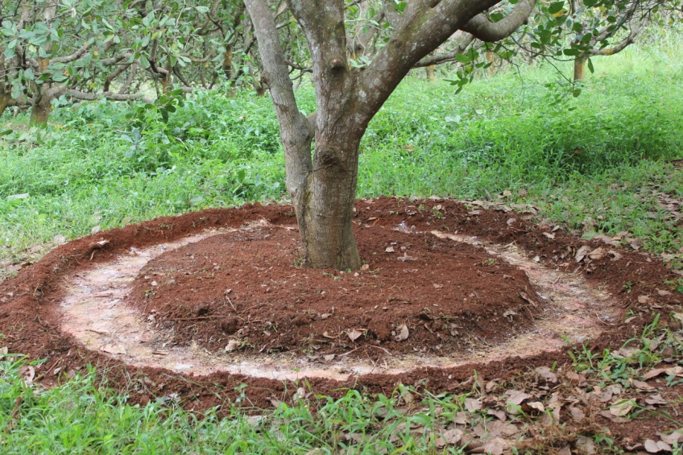
Micronutrient management in cashew plantations
Widespread occurrences of deficiencies of micronutrients such as zinc and boron have been reported in Karnataka. The deficiency of micronutrient can be known from the deficiency symptoms on cashew leaves and this can be ascertained by soil testing or leaf analysis. Micronutrient deficiencies can be corrected by either soil or foliar application. Excess application of micronutrients leads to more damage than non-application, by inhibiting the availability of other nutrients.
Foliar application of nutrients is the quickest way to correct nutrient deficiencies in cashew. Major nutrients can also be applied through foliar application. The recommended doses of foliar application of major and micronutrients are given below.
Nutrient | Fertiliser to be used | Rate (g/litre) | Instruction
Nitrogen | Urea | 30 | The foliar spray is to be carried out at weekly intervals till the symptoms disappear
Phosphorus | Phosphoric acid | 5 | The foliar spray is to be carried out at weekly intervals till the symptoms disappear
Potassium | Potassium sulphate | 10 | The foliar spray is to be carried out at weekly intervals till the symptoms disappear
Magnesium | Magnesium sulphate | 5 | The foliar spray is to be carried out at the emergence of flush, panicle initiation and fruit setting stages
Iron | Ferrous sulphate | 5 | The foliar spray is to be carried out at the emergence of flush, panicle initiation and fruit setting stages
Manganese | Manganese sulphate | 5 | The foliar spray is to be carried out at the emergence of flush, panicle initiation and fruit setting stages
Zinc | Zinc sulphate hepta hydrate | 5 | The foliar spray is to be carried out at the emergence of flush, panicle initiation and fruit setting stages
Boron | Boric acid | 1 | The foliar spray is to be carried out at the emergence of flush, panicle initiation and fruit setting stages
 | Solubor | 1 | The foliar spray is to be carried out at the emergence of flush, panicle initiation and fruit setting stages
 | Borax | 1 | The foliar spray is to be carried out at the emergence of flush, panicle initiation and fruit setting stages
Molybdenum | Ammonium molybdate | 1 | The foliar spray is to be carried out at the emergence of flush, panicle initiation and fruit setting stages
Copper | Copper sulphate penta hydrate | 1 | The foliar spray is to be carried out at the emergence of flush, panicle initiation and fruit setting stages
The approximate quantity of spray liquid required for a fully grownup tree is 5 litres.

